**COSMETICS STORE MANAGEMENT**

**Project abstract**

**COSMETICS STORE MANAGEMENT**

Cosmetics Store Management in Salesforce is an integrated solution tailored for the cosmetics retail industry, aimed at enhancing operational efficiency and customer engagement. Built on Salesforce's versatile and scalable platform, it equips cosmetics stores with tools to manage customer relationships, inventory, sales, and marketing activities seamlessly. The solution enables real-time inventory tracking, automated sales processes, and personalized customer experiences, helping stores meet customer demands with precision. Additionally, it provides comprehensive analytics and reporting, allowing businesses to make data-driven decisions that drive profitability and growth. By centralizing operations on the Salesforce platform, the solution fosters a holistic approach to customer service, inventory management, and business expansion, empowering cosmetics retailers to adapt quickly to market trends and deliver superior customer satisfaction. This results in improved workflow efficiency, enhanced brand loyalty, and a competitive edge in a dynamic marketplace.

The Cosmetics Store Management solution in Salesforce goes beyond basic inventory and sales tracking by integrating advanced features such as loyalty programs, targeted marketing campaigns, and customer insights through AI-driven analytics. With the ability to segment customers based on purchase history, preferences, and behaviour, stores can tailor their marketing efforts and deliver personalized offers, boosting customer retention and satisfaction.

**INTRODUCTION**

**Salesforce**

Are you new to Salesforce? Not sure exactly what it is, or how to use it? Don’t know where you should start on your learning journey? If you’ve answered yes to any of these questions, then you’re in the right place. This module is for you.

Welcome to Salesforce! Salesforce is game-changing technology, with a host of productivity- boosting features, that will help you sell smarter and faster. As you work toward your badge for this module, we’ll take you through these features and answer the question, “What is Salesforce, anyway?”.

What Is Salesforce?

Salesforce is your customer success platform, designed to help you sell, service, market, analyze, and connect with your customers.

Salesforce has everything you need to run your business from anywhere. Using standard products and features, you can manage relationships with prospects and customers, collaborate and engage with employees and partners, and store your data securely in the cloud.

So what does that really mean? Well, before Salesforce, your contacts, emails, follow-up tasks, and prospective deals might have been organized something like this: https://youtu.be/r9EX3lGde5k

**SALESFORCE:**

* Creating Developer Account
* Account Activation

**TASK 1**: Creating Developer Account

Creating a developer org in salesforce.

1. Go to https://developer.salesforce.com/signup
2. On the sign up form, enter the following details :

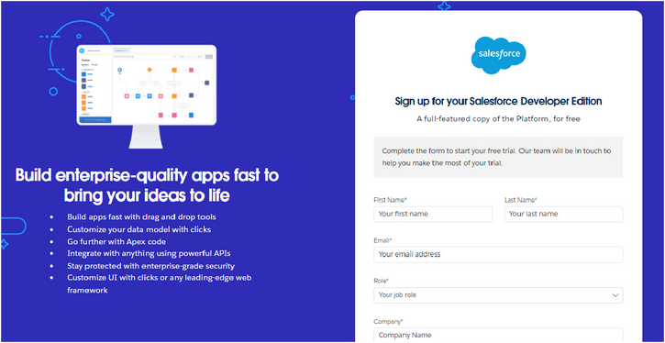

* 1. First name & Last name
  2. Email
  3. Role: Developer
  4. Company: College Name
  5. County: India
  6. Postal Code : pin code

Username: should be a combination of your name and company

This need not be an actual email id, you can give anything in the format: [username@organization.com](mailto:username@organization.com)

Click on sign me up after ﬁlling these.

**TASK 2** :- Account Activation

1. Go to the inbox of the email that you used while signing up. Click on the verify account to activate your account. The email may take 5-10mins.

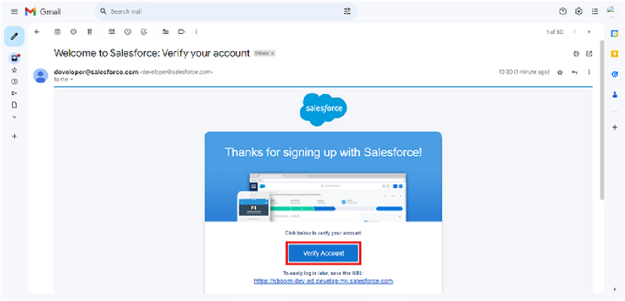

1. Click on Verify Account
2. Give a password and answer a security question and click on change password.

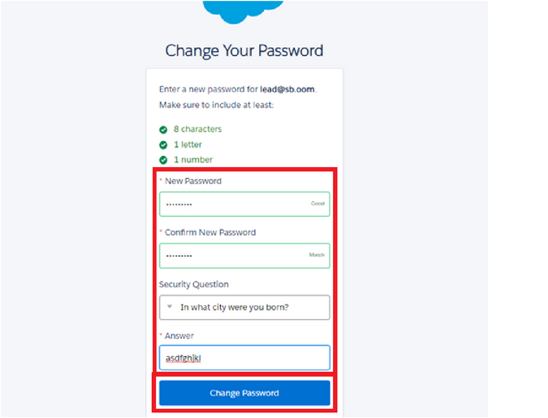

# **2. Object**

**INTRODUCTION :**

What Is an Object?

Salesforce objects are database tables that permit you to store data that is speciﬁc to an organization. What are the types of Salesforce objects Salesforce objects are of two types:

1. Standard Objects: Standard objects are the kind of objects that are provided by salesforce.com such as users, contracts, reports, dashboards, etc.
2. Custom Objects: Custom objects are those objects that are created by users. They supply information that is unique and essential to their organization. They are the heart of any application and provide a structure for sharing data.

To Navigate to Setup page: Click on gear icon Click setup.

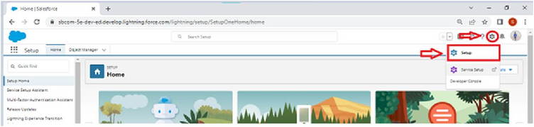

Objects and ﬁelds involved in Co-Living:

OBJECT :-

* Create a custom object for Our Customer
* Create a custom object for Consultants
* Create a custom object for Retailers
* Create a custom object for Others

**To Create an object:**

Creation of Objects for Urban Colour, For this Urban Colour we need to create 3 objects

Our Customers, Consultants, Retailers, others.

The below steps will assist you in creating those objects.

* Click on the gear icon and then select Setup.
* Click on the object manager tab just beside the home tab.
* After the above steps, have a look on the extreme right you will find a Create Dropdown click on that and select Custom Object.
* Creation of Our Customer Object

**Our Customer Object Creation(example)**

On the Custom Object Definition page, create the object as follows:

* Label: Our Customer
* Plural Label: Our Customers
* Record Name: Our Customer
* Check the Allow Reports checkbox
* Check the Allow Search checkbox
* Click Save.
* Now create a custom tab. Click the Home tab, enter Tabs in Quick Find and select Tabs.
* Under Custom Object Tabs, click New.
* For Object, select Our Customer.
* For Tab Style, select any icon.
* Leave all defaults as is. Click Next, Next, and Save.

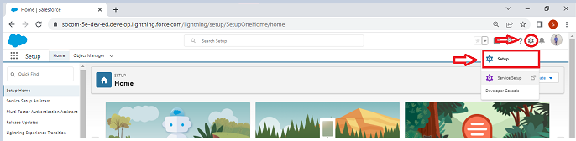

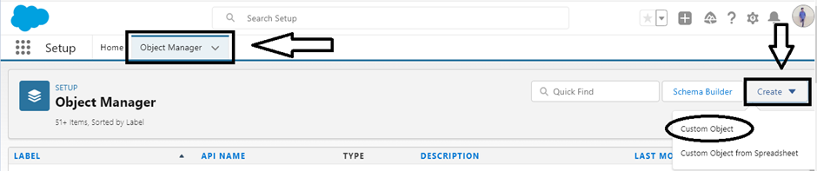

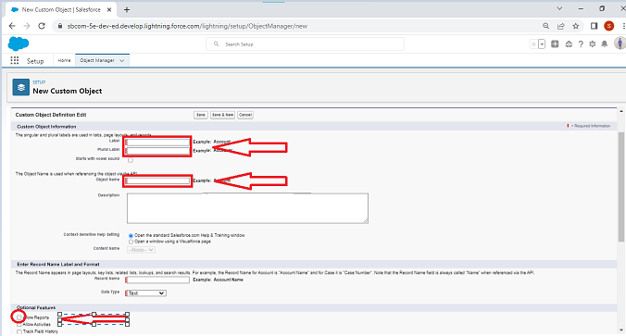

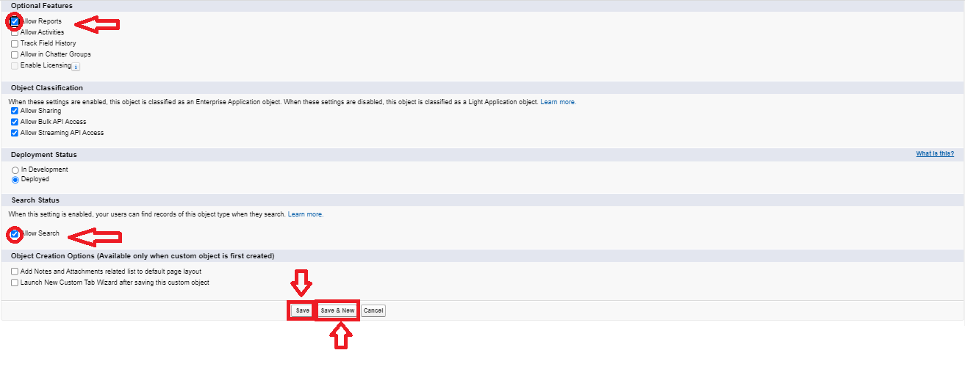

**3.Fields and Relationship**

An object relationship in Salesforce is a two-way association between two objects. Relationships are created by creating custom relationship fields on an object. This is done so that when users view records, they can also see and access related data.

**Fields in Our Customers objects**

Fields in Our Customers objects follow below data types:

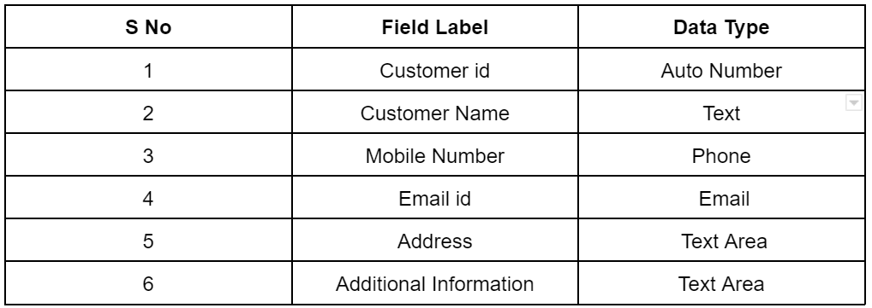

**Fields in Consultants objects**

Fields in Consultants objects follow below data types:

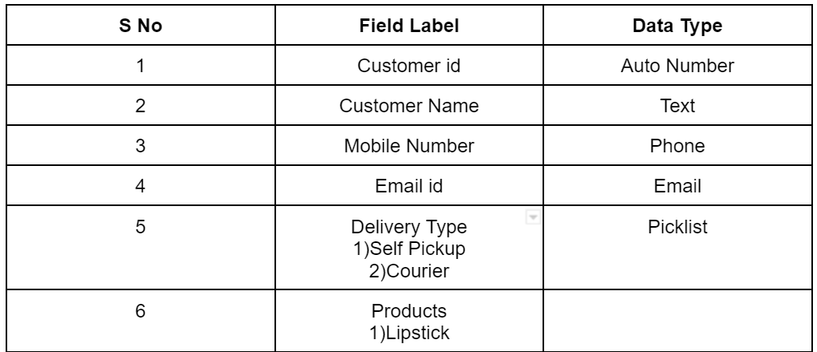

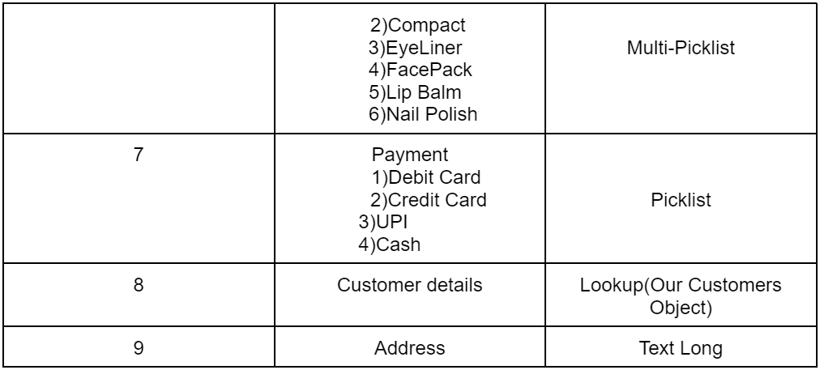

**Fields in Retailers objects**

Fields in Retailers objects follow below data types:

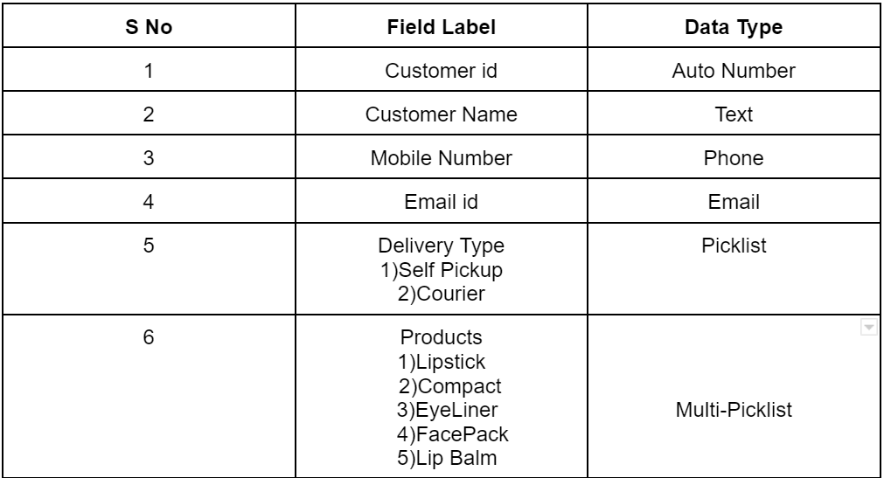

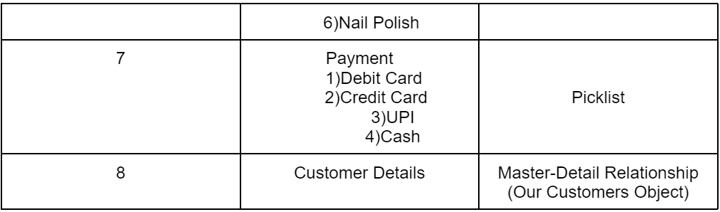

**Fields in Others objects**

Fields in Others objects follow below data types:

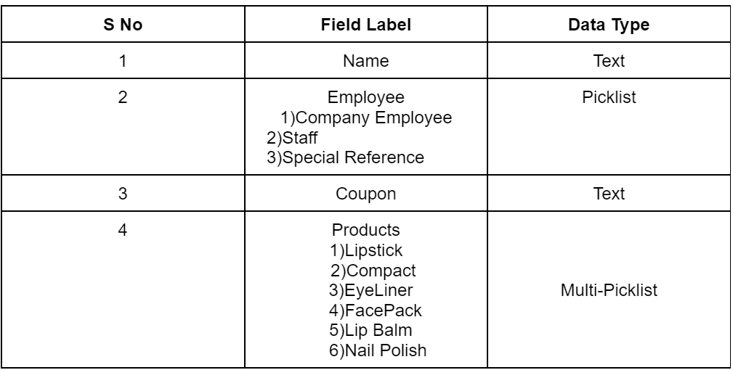

**4.Page Layouts**

In Salesforce, page layouts define the organisation and arrangement of fields, buttons, related lists, and other components on an object's detail and edit pages. They allow you to control the user interface and tailor it to meet the specific needs of your organisation.

**Page Layout Creation**

1. From the Salesforce setup menu, go to "Object Manager" and select the Consultants object.
2. Click on "Page Layouts" in the left sidebar. This will display a list of available page layouts for the selected object.
3. Select the Consultant Layout page layout.

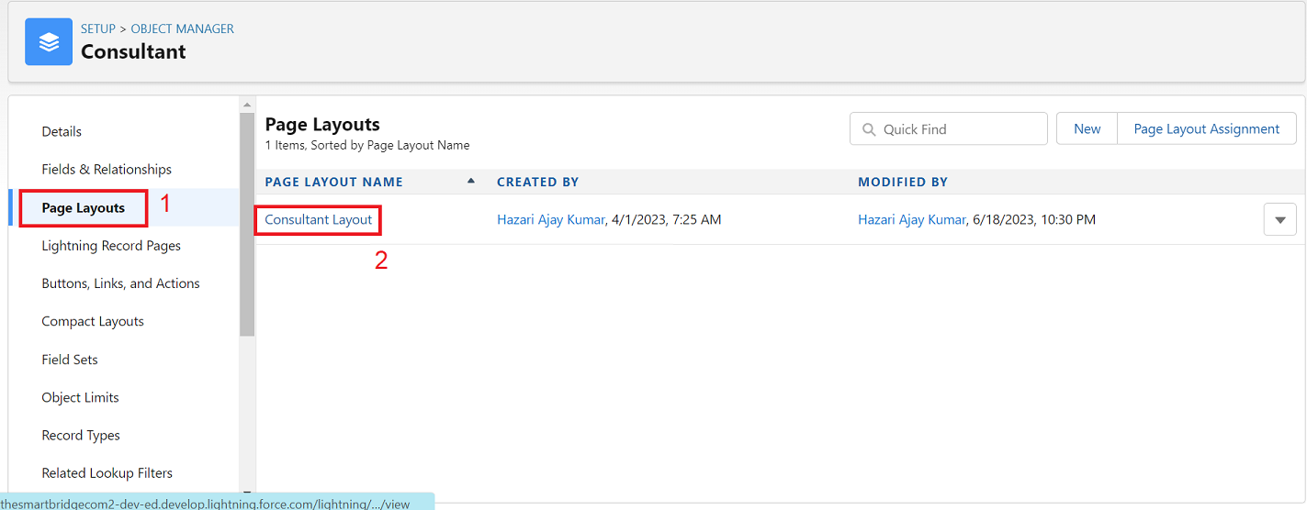

1. Click And Drag Delivery type and Address Fields Below Phone field

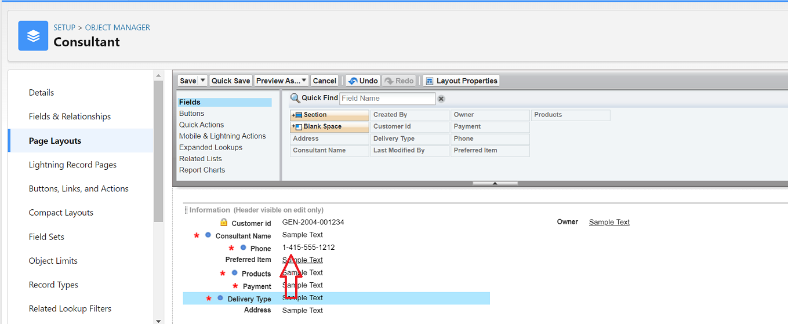

1. Click on Save

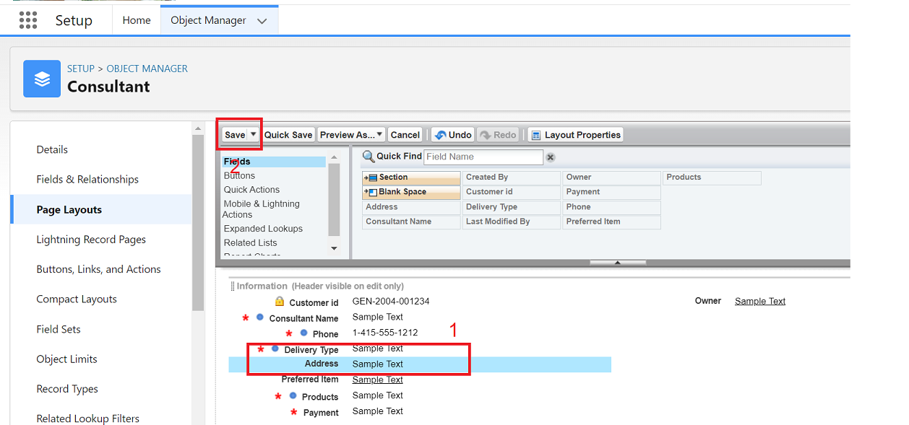

**5.The Lightning App**

**The Lightning App**

An app is a collection of items that work together to serve a particular function. In Lightning Experience, Lightning apps give your users access to sets of objects, tabs, and other items all in one convenient bundle in the navigation bar.

Lightning apps let you brand your apps with a custom Colour and logo. You can even include a utility bar and Lightning page tabs in your Lightning app. Members of your org can work more efficiently by easily switching between apps.

**Create a Lightning App**

To create a lightning app page:

1. Go to setup page --> search “app manager” in quick find --> select “app manager” --> click on New lightning App.

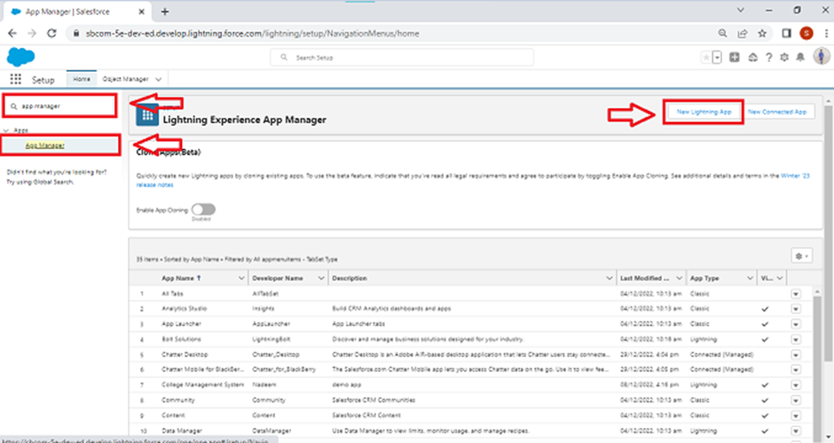

Fill the app name as Urban Colour in app details and branding --> Next --> (App option page) keep it as default --> Next --> (Utility Items) keep it as default --> Next.

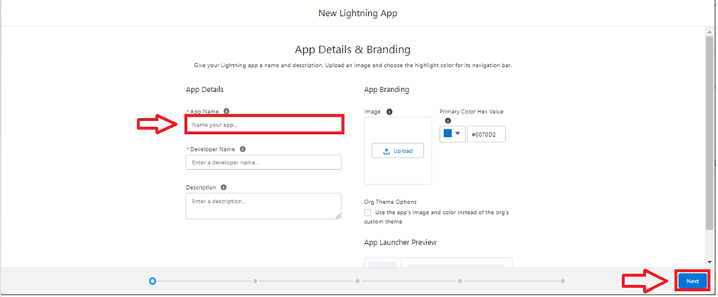

3.To Add Navigation Items:

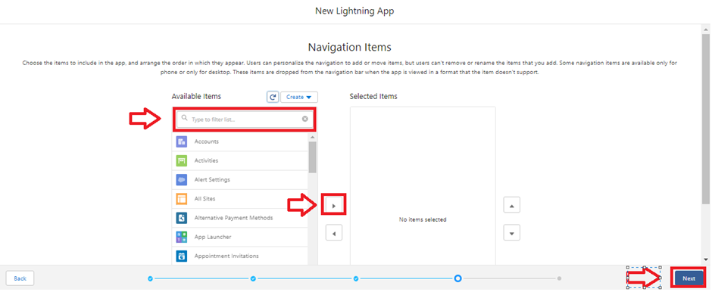

1. Select the items (Our Customers, Consultants, Retailers, Others, Reports, Dashboards) from the search bar and move it using the arrow button --> Next.
2. To Add User Profiles:

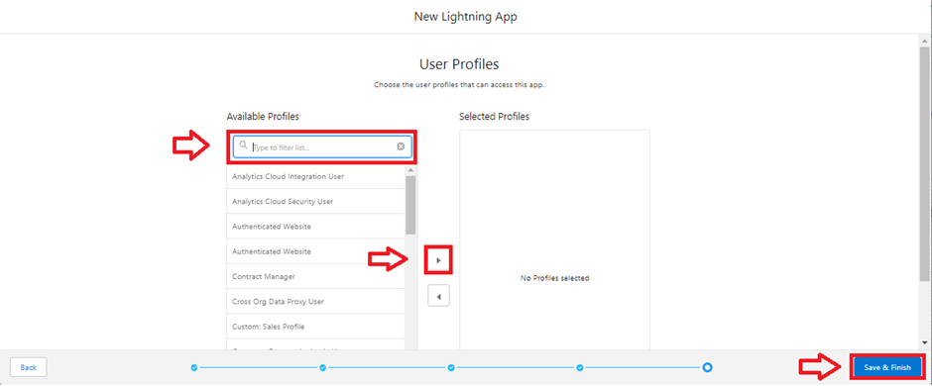

1. Search profiles (System administrator) in the search bar --> click on the arrow button --> save & finish.

### **6.Profile**

A profile is a group/collection of settings and permissions that define what a user can do in salesforce. A profile controls “Object permissions, Field permissions, User permissions, Tab settings, App settings, Apex class access, Visualforce page access, Page layouts, Record Types, Login hours & Login IP ranges.

**Creating a Profiles**

Creating a Profiles: Now create a Store Supervisor profile and set its object permissions.

Creating a Profiles:

Now create a Store Supervisor profile and set its object permissions.

* From Setup enter Profiles in the Quick Find box, and select Profiles.
* From the list of profiles, find Standard User.
* Click Clone.
* For Profile Name, enter Store Supervisor.
* Click Save.
* While still on the Store Supervisor profile page, then click Edit.
* Scroll down to Custom Object Permissions and give access for Create, Read, Edit, Delete, View all and modify all for Our Customers, Consultants, Retailers, Others.
* Scroll down to Custom App Settings and give access for Urban Colour.

To create a new profile:

1. Go to setup --> type profiles in quick find box --> click on profiles --> clone the desired profile (standard user is preferable) --> enter profile name --> save.

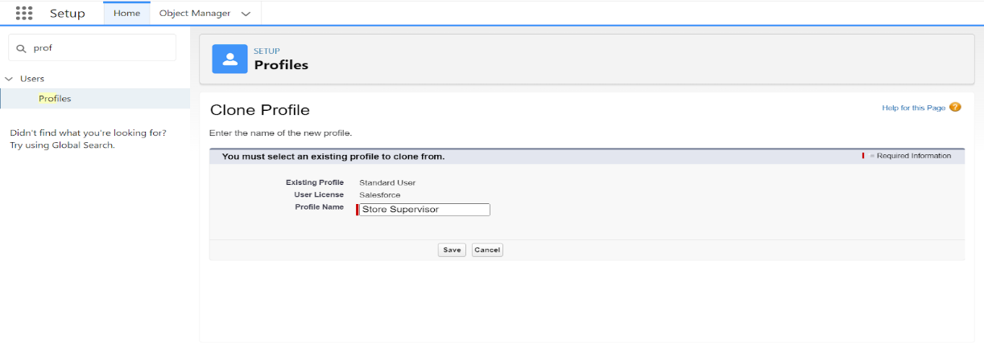

2.While still on the profile page, then click Edit.

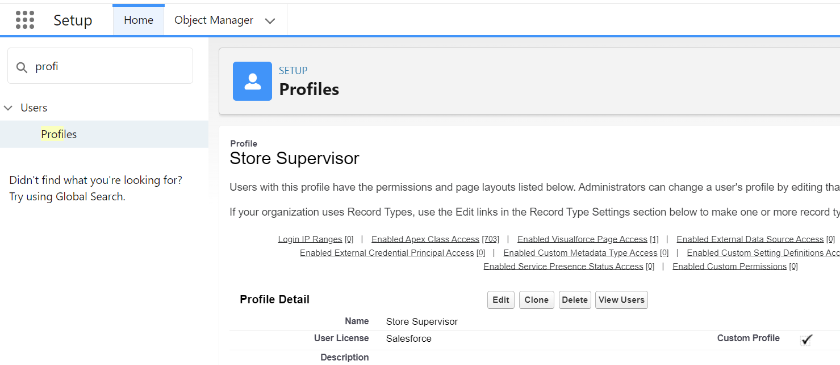

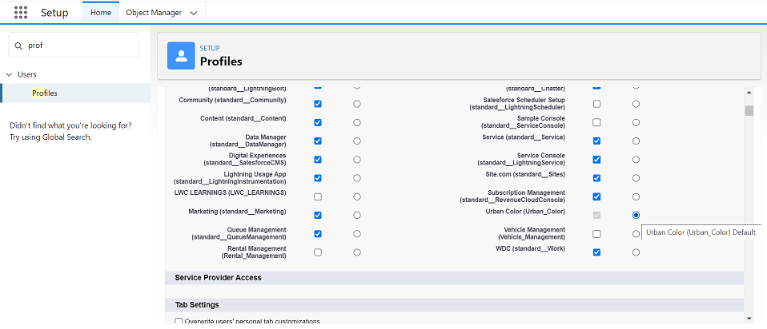

3.Scroll down to the Custom object permission and give all access to the Consultants, Others, Our Customers, Retailers object.

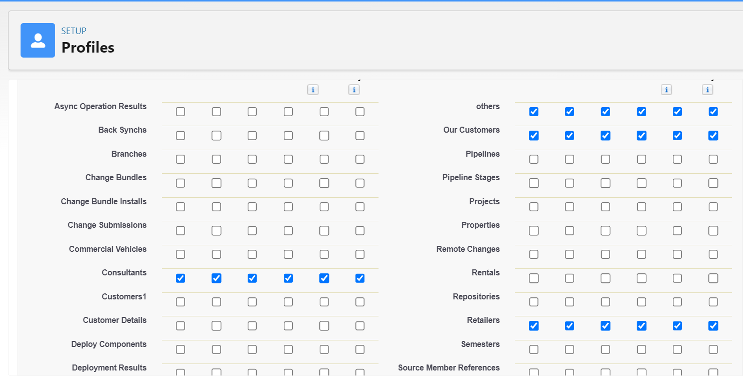

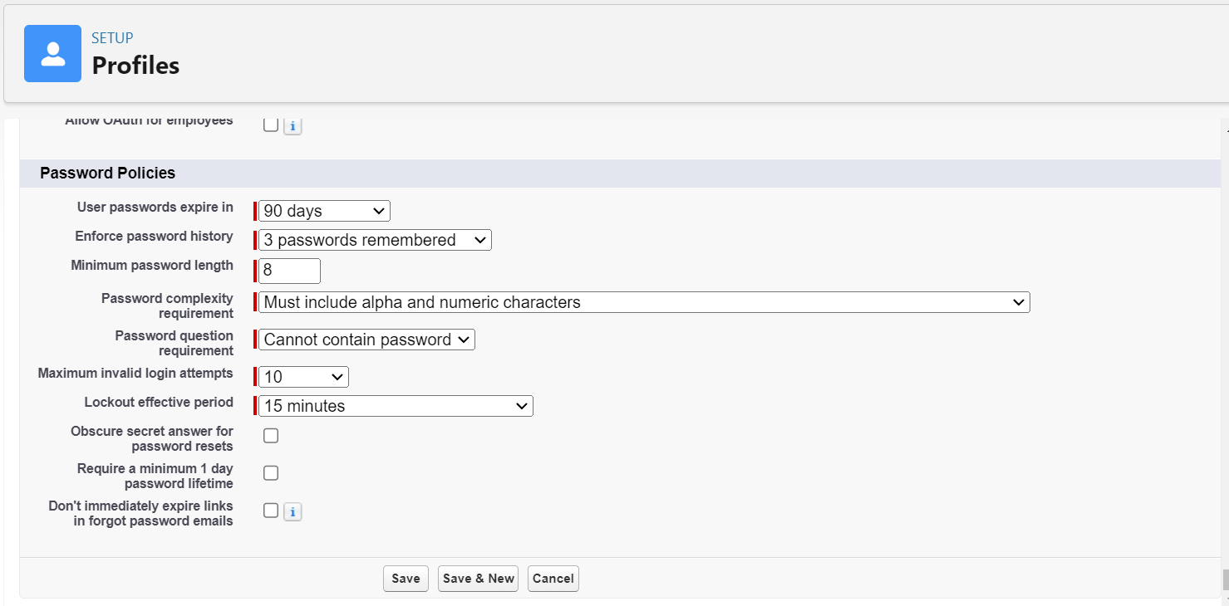

1. Click on Save.
2. Similarly Create operator profile ,Clone Salesforce Platform user and give access only for Billing Operator.

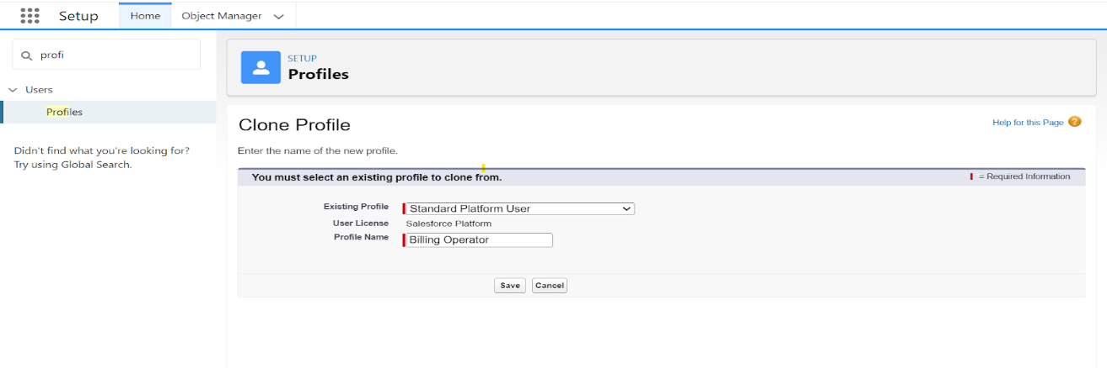

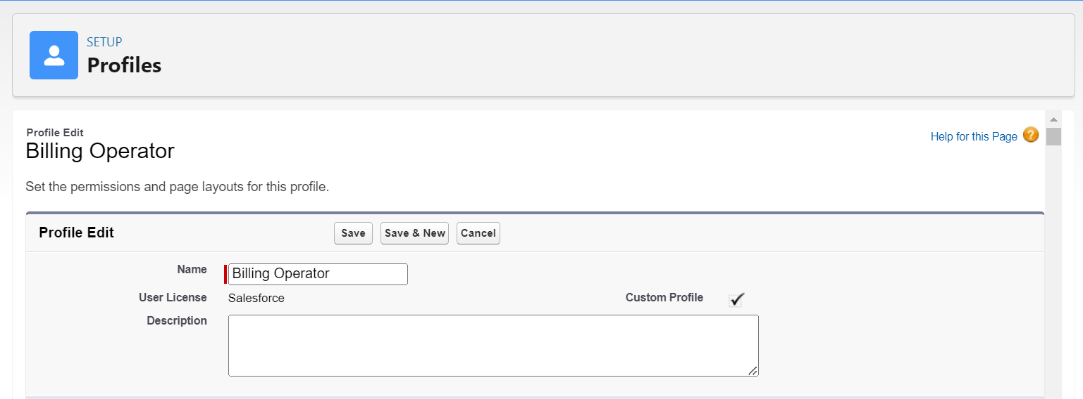



1. Click on save

**7.Setup Roles**

Roles are record-level access controls that define what data a user can see in Salesforce.

**Setup Roles**

1. Click on the Gear Icon

2. Click "Setup"

3. In the Quick Find box, enter "Roles"

4. Click "Roles"

5. Click on "Set Up Roles"

6. Click "Expand All"

7. Under the CEO, click on "Add Role"

8. Fill up the Label as Store Head, Role Name Store Head.

9. Enter a Role name that will be displayed on Reports

10. Click on Save .

Similarly create One Roles under Store Head as Billing Operator.

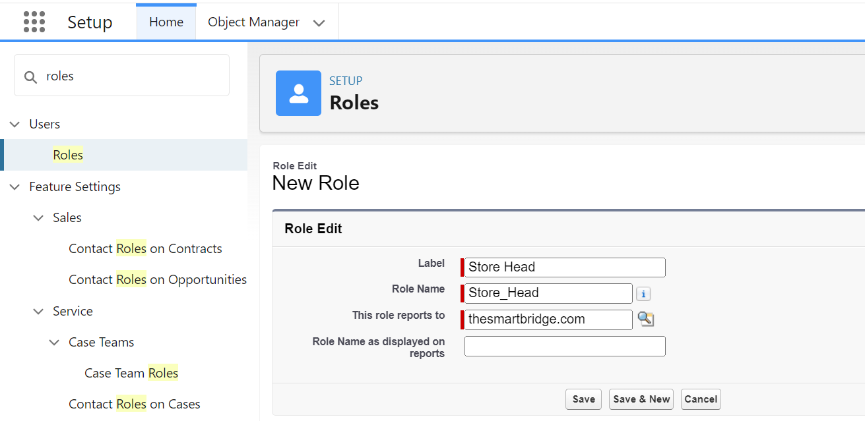

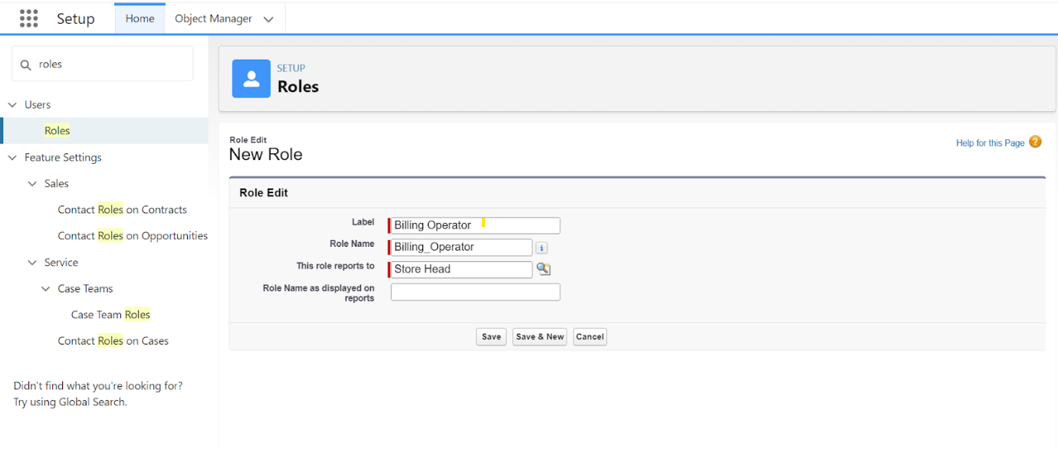

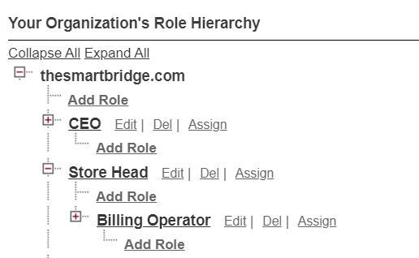

**Users**

A user is anyone who logs in to Salesforce. Users are employees at your company, such as sales reps, managers, and IT specialists, who need access to the company's records. Every user in Salesforce has a user account.

**Creating a Users:**

1. From Setup, in the Quick Find box, enter Users, and then select Users.
2. Click New User.
3. Enter the user’s name Amar K and (Your) email address and a unique username in the form of an email address. By default, the username is the same as the email address.
4. Select a Role(Store Head)
5. Select a User License as Salesforce.
6. Select a profile as Store Supervisor.
7. Check Generate new password and notify the user immediately to have the user’s login name and a temporary password emailed to your email.

Fill in the fields (first name, last name, alias, email id, username, nick name, role, user licence, profiles) --> save.

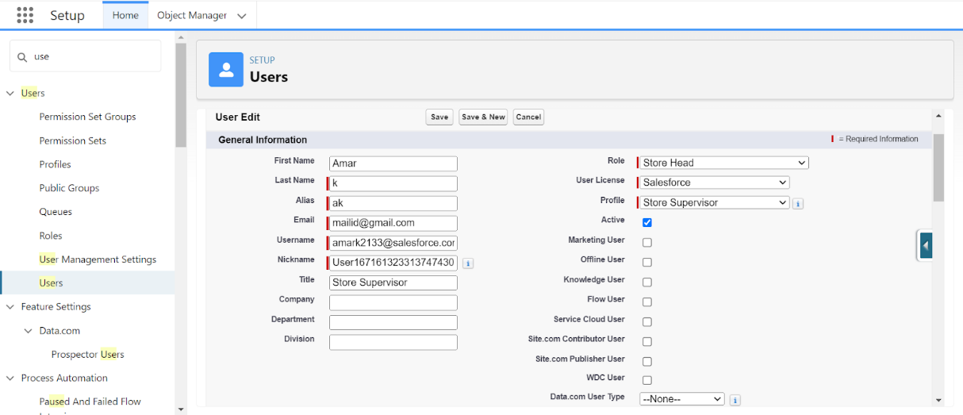

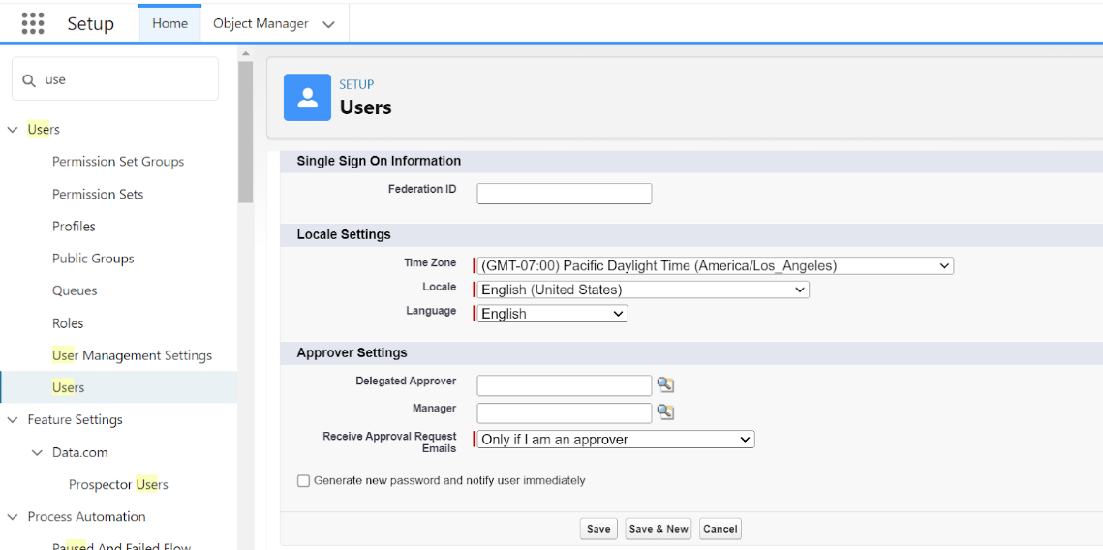

**Second User Creation**

1. From Setup, in the Quick Find box, enter Users, and then select Users.
2. Click New User.
3. Enter the user’s name John Teddy and (Your) email address and a unique username in the form of an email address. By default, the username is the same as the email address.
4. Select a Role(Billing Operator)
5. Select a User Licence As Salesforce Platform.
6. Select a profile as Billing Operator.
7. Check Generate new password and notify the user immediately to have the user’s login name and a temporary password emailed to your email.

Fill in the fields (first name, last name, alias, email id, username, nick name, role, user licence, profiles) --> save.

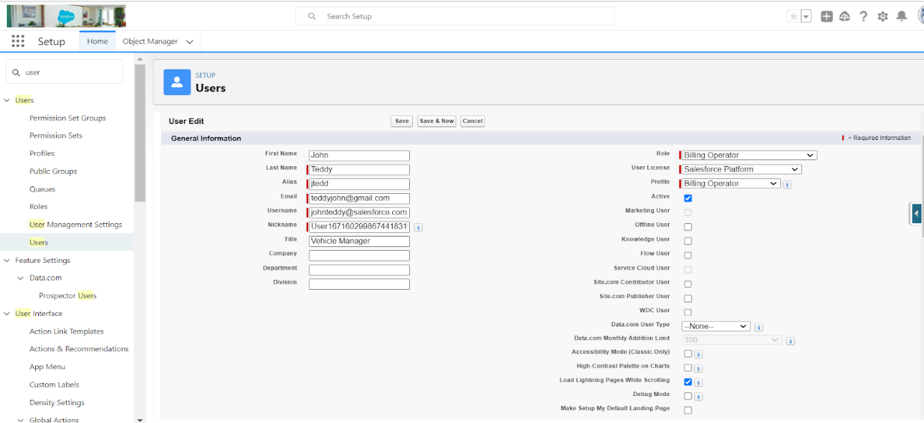

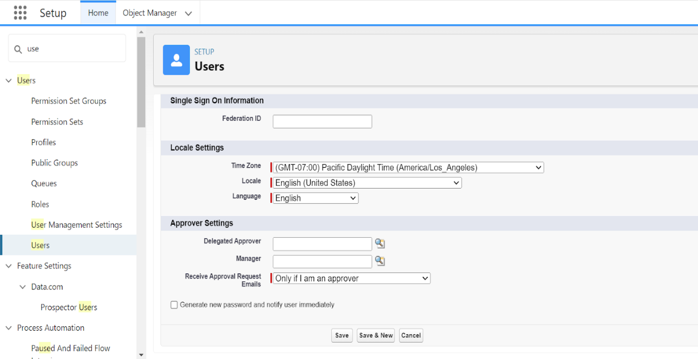

**User Adoption**

We need to understand user adoption and navigation. How to interact with database and their records.

**Create Our Customer Record**

1. Click on App Launcher on left side of screen.
2. Search Urban Colour & click on it.
3. Click on Our Customer tab.
4. Click new button
5. Fill all Our Customer record details.
6. Click on Save Button

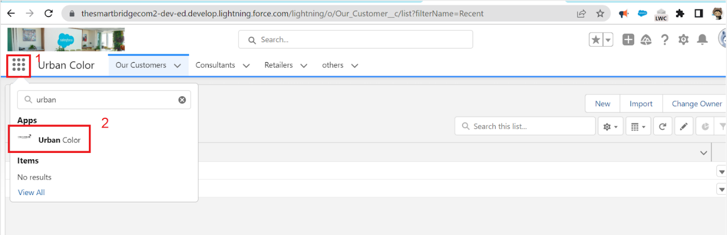

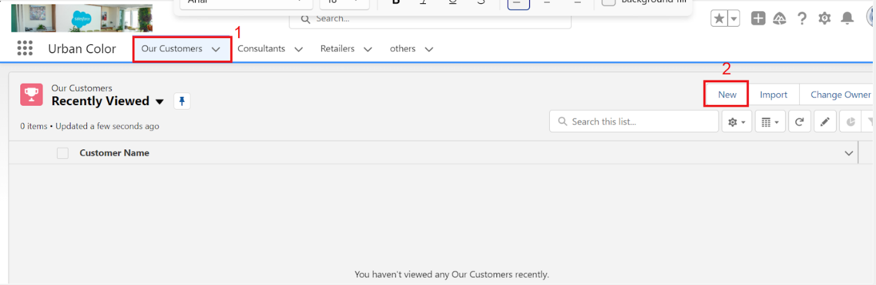

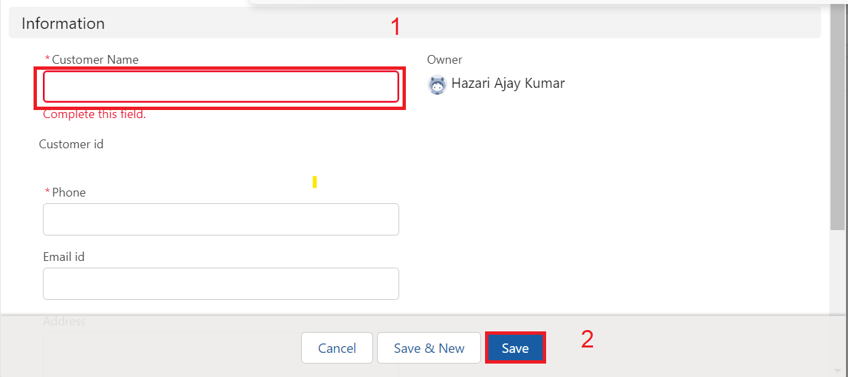

**View Record (Our Customer)**

View Record (Our Customer):

1. Click on App Launcher on the left side of the screen.
2. Search Urban Color & click on it.
3. Click on Our Customer Tab.
4. Click on any record name. you can see the details of the Our Customer

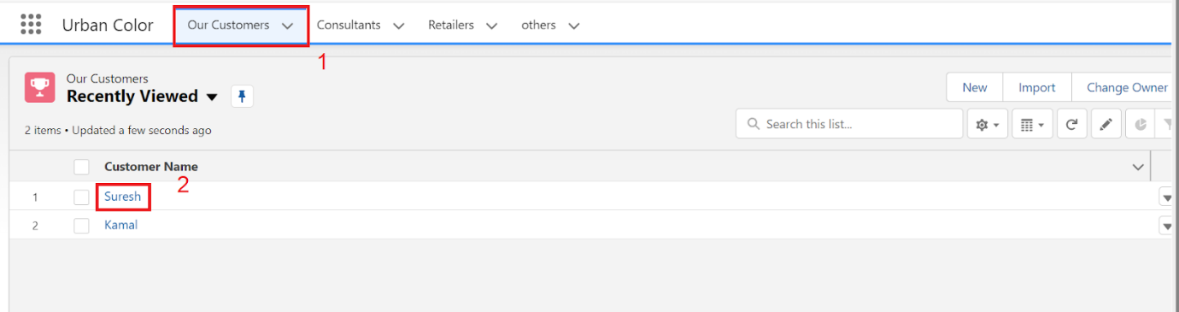

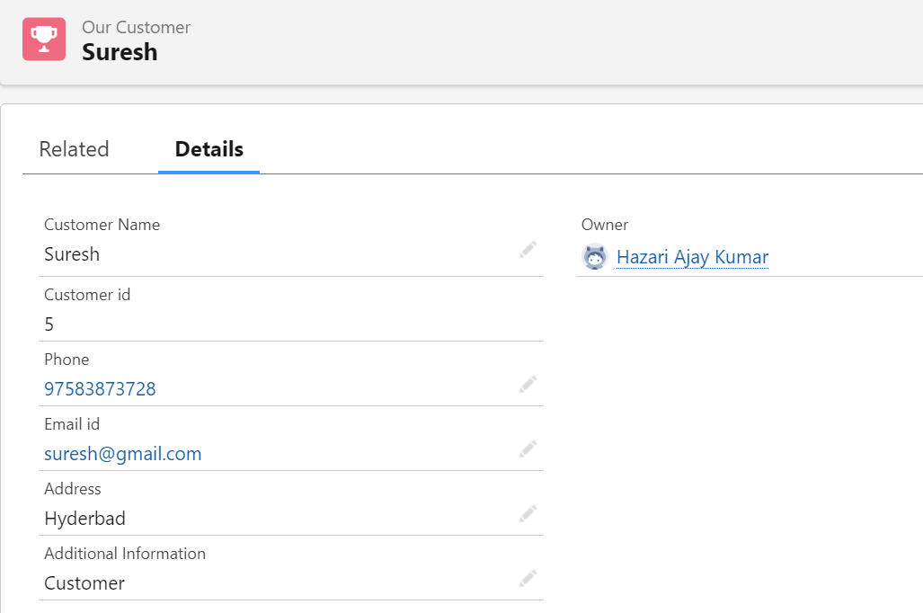

**Delete Record (Our Customer)**

Delete Record (Our Customer):

1. Click on App Launcher on the left side of the screen.
2. Search Urban Colour & click on it.
3. Click on Our Customer Tab.
4. Click on Arrow at right hand side on that Particular record.
5. Click delete and delete again.

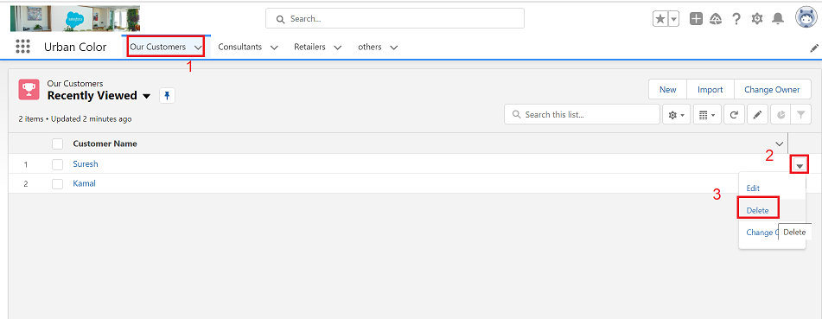

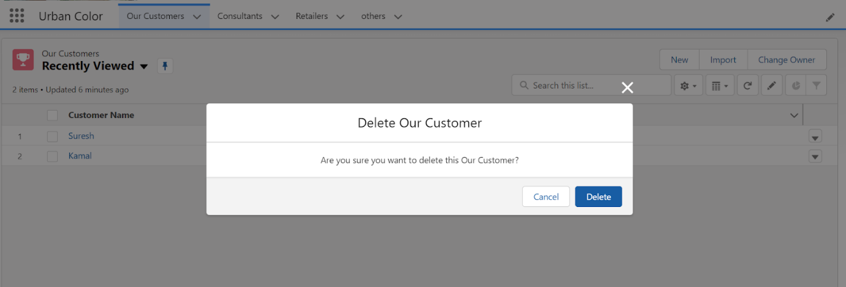

**Import Data**

Data Import Wizard—this tool, accessible through the Setup menu, lets you import data in common standard objects, such as contacts, leads, accounts, as well as data in custom objects.

**To Import Data**

1.From Setup, click the Home tab.

2.In the Quick Find box, enter Data Import and select Data Import Wizard

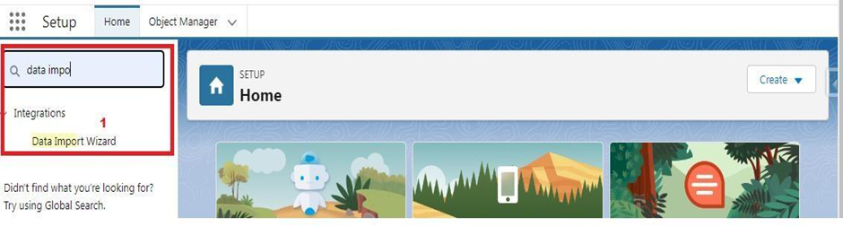

3.Click Launch Wizard!

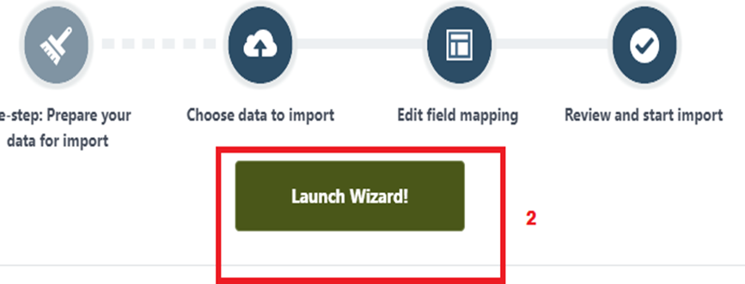

4.Click the Custom Objects tab and select the Consultant object.

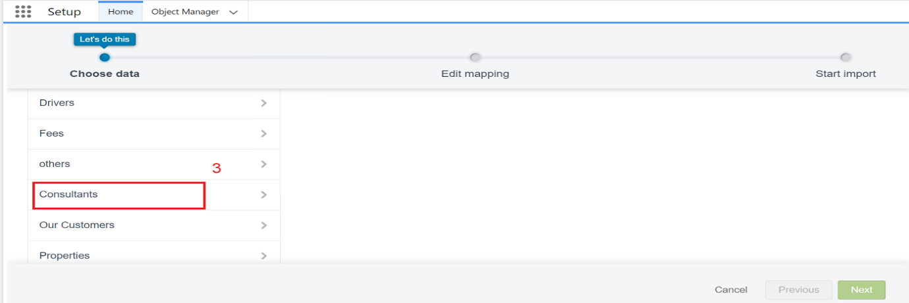

5.Select Add new records.

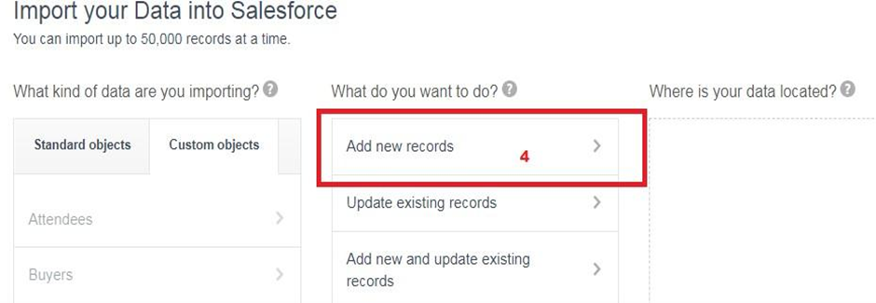

6.Click CSV and choose file Consultant_CSV which we made earlier. Click Next.

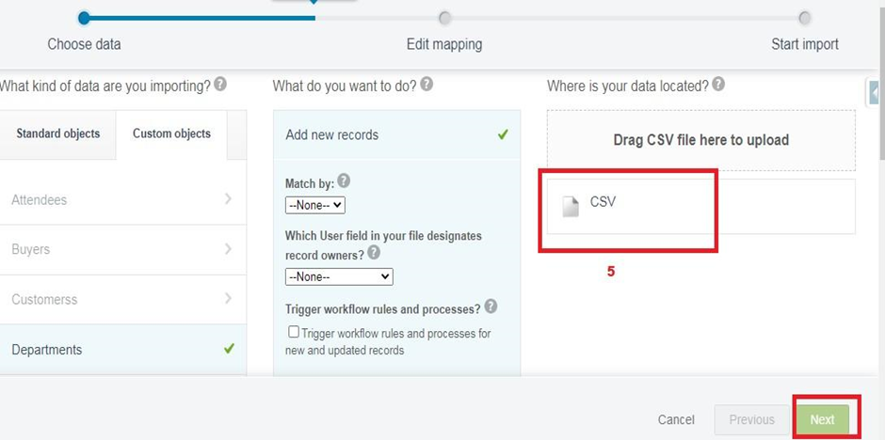

7.Since the field names in the CSV file (CSV Header) are the same as the field names in your object (Mapped Salesforce Object), the fields are automatically mapped. Click Next.

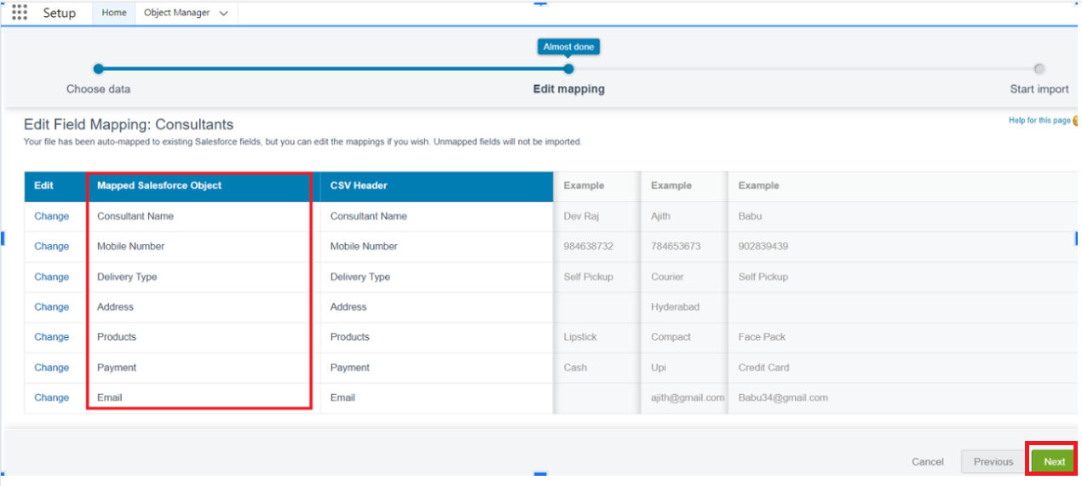

8.The next screen gives you a summary of your data import. Click Start Import.

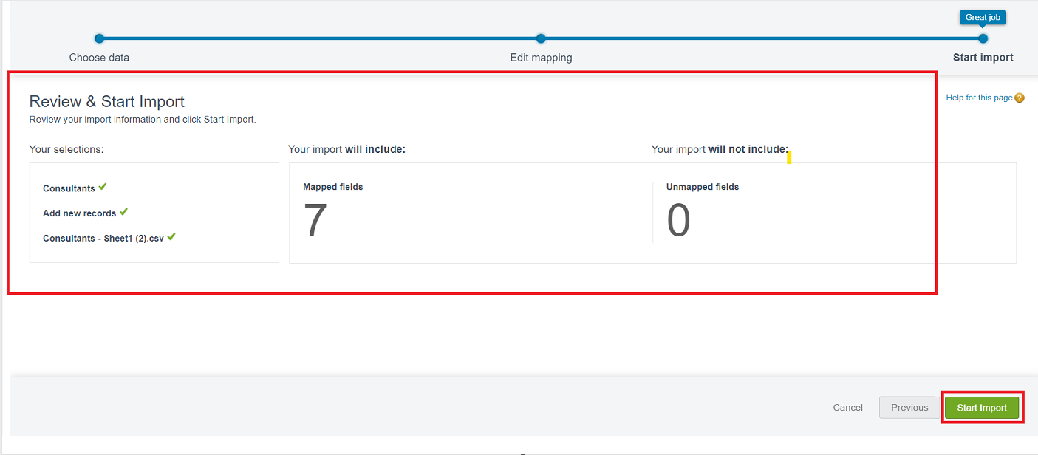

9.Click OK on the popup.

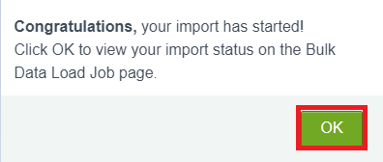

10.Scroll down the page and verify that your data has been imported under batches.



11.Make sure you have 0 records under the records failed column.

What are Reports?

**Reports:**

Reports in Salesforce is a list of records that meet a particular criterion which gives an answer to a particular question. These records are displayed as a table that can be filtered or grouped based on any field.

There are 4 types of report formats in Salesforce:

1. Tabular Reports:  
   This is the most basic report format. It just displays the row of records in a table with a grand total. While easy to set up they can’t be used to create groups of data or charts and also cannot be used in Dashboards. They are mainly used to generate a simple list or a list with a grand total.
2. Summary Reports:  
   It is the most commonly used type of report. It allows grouping of rows of data, view subtotal, and create charts.
3. Matrix Report:  
   It is the most complex report format. Matrix report summarizes information in a grid format. It allows records to be grouped by both columns and rows. It can also be used to generate dashboards. Charts can be added to this type of report.
4. Joined Reports:  
   These types of reports let us create different views of data from multiple report types. The data is joined reports are organized in blocks. Each block acts as a sub report with its own fields, columns, sorting, and filtering. They are used to group and show data from multiple report types in different views.

**Report types:**

Report type determines which set of records will be available in a report. Every report is based on a particular report type. The report type is selected first when we create a report. Every report type has a primary object and one or more related objects. All these objects must be linked together either directly or indirectly.

* A report type cannot include more than 4 objects.
* Once a report is created its report type cannot be changed.

There are 2 types of report types:

1. **Standard Report Types:**Standard Report Types are automatically included with standard objects and also with custom objects where “Allow Reports” is checked.  
   Standard report types cannot be customized and automatically include standard and custom fields for each object within the report type. Standard report types get created when an object is created, also when a relationship is created.  
   **Note:** Standard report types always have inner joins.
2. **Custom Report Types:**  
   Custom report types are reporting templates created to streamline the reporting process. Custom Reports are created by an administrator or User with “Manage Custom Report Types” permission. Custom report types are created when standard report types cannot specify which records will be available on reports.  
   In custom report types we can specify objects which will be available in a particular report. The primary object must have a relationship with other objects present in a report type either directly or indirectly.

There are 3 types of access levels of folders:

1. Viewer:  
   With this access level, users can see the data in a report but cannot make any changes except cloning it into a new report.
2. Editor:  
   With this access level, users can view and modify the reports it contains and can also move them to/from any other folders they have access level as Editor or Manager.
3. Manager:  
   With this access level, users can do everything Viewers & Editors can do, plus they can also control other user’s access levels to this folder. Also, users with Manager Access levels can delete the report.

### **Create Report**

1.Click App Launcher

2.Select Urban Colour App

3.Click reports tab

4.Click New Report.

5.Click the report type as Consultants Click Start report.

6.Customize your report, in Columns  select – Consultant Name, Delivery type, Products, Payment.

7.Click on the drop down option on the payment column and select Bucket this column.

8.Bucket Name as Payment type

9.Click on Add Bucket and name it as NetBanking

10.Click on Add Bucket and name it as Cash

11.Now Click on All Values and select Credit card, Debit card, UPI and Move to Net Banking.

12.Now Click on All Values again and select Cash and Move to Cash.

13.Click on Apply.

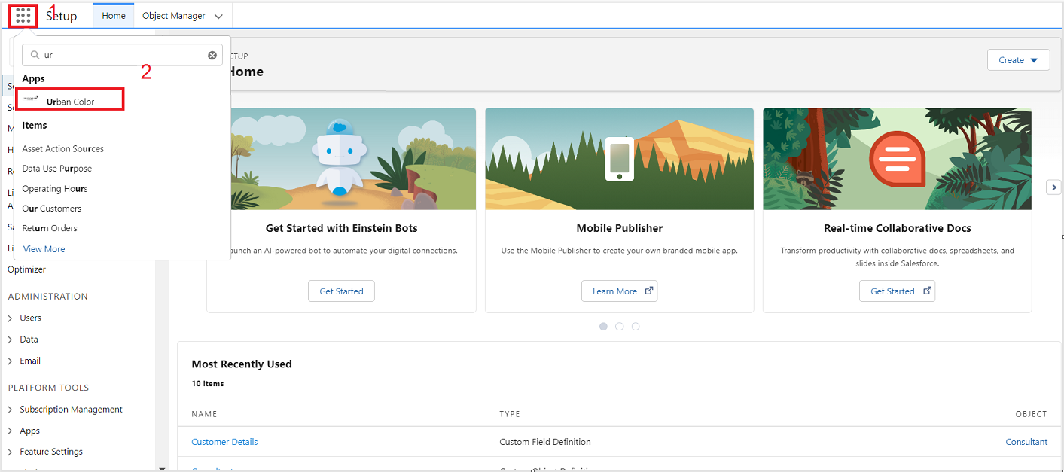

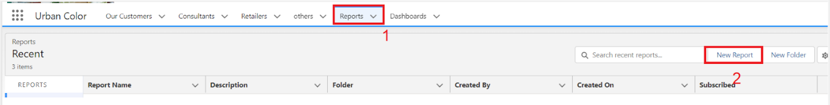

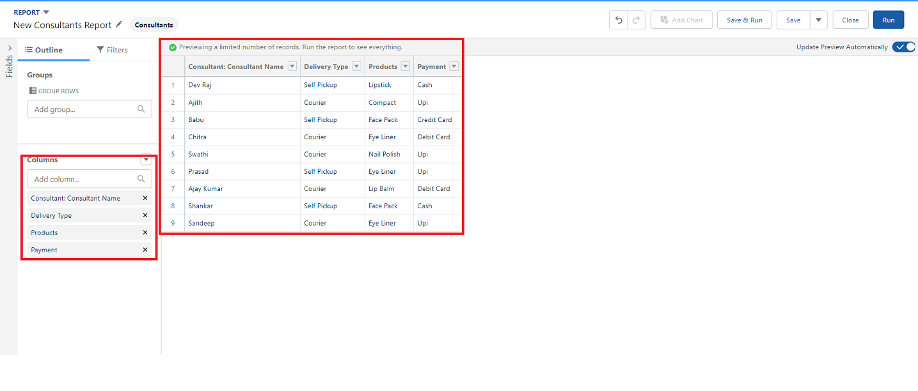

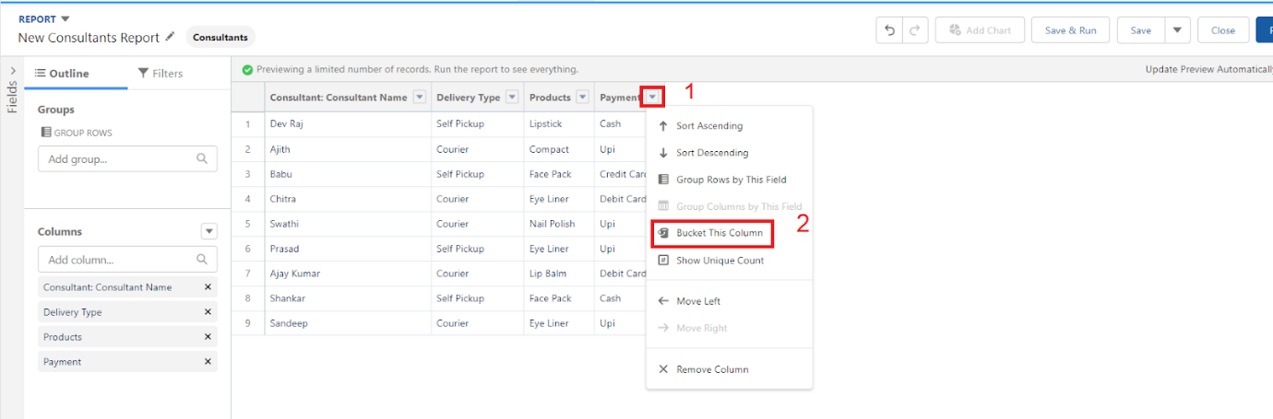

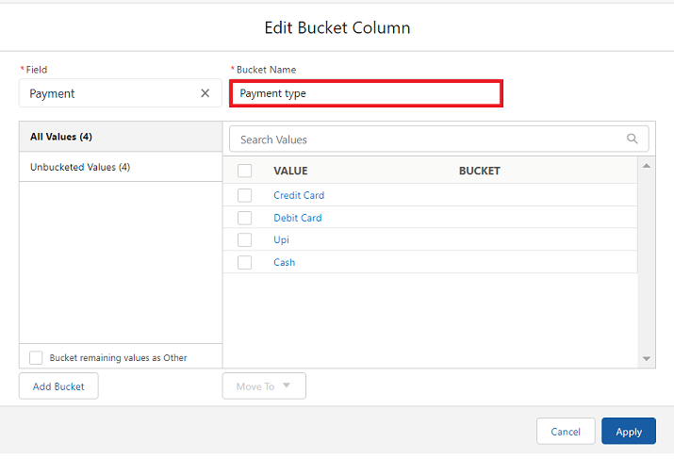

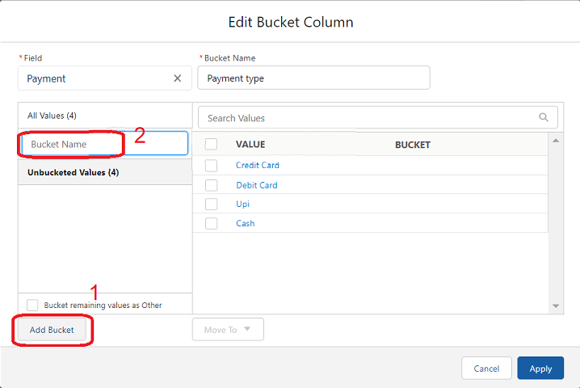

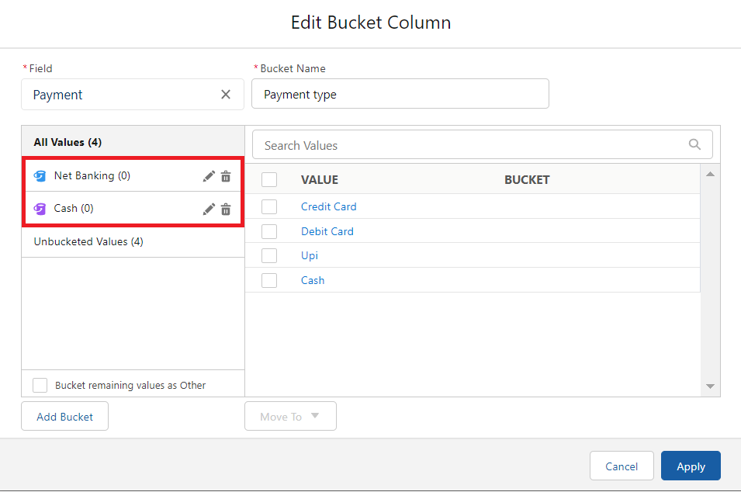

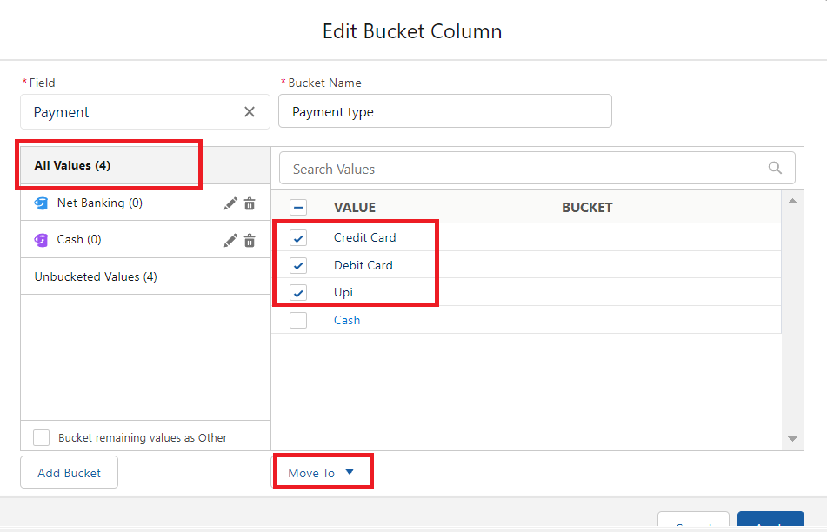

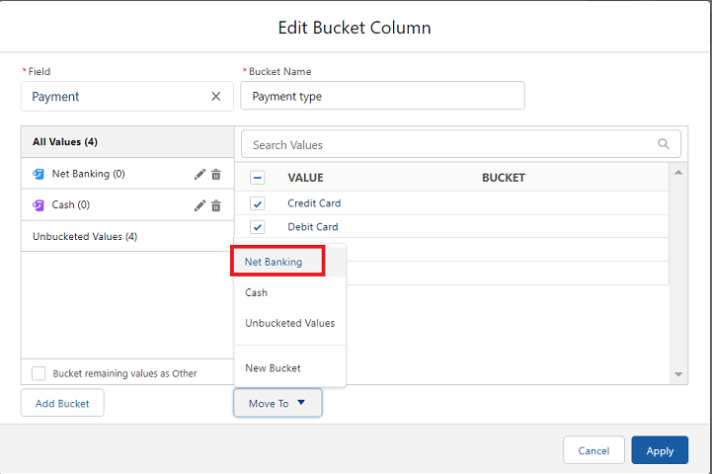

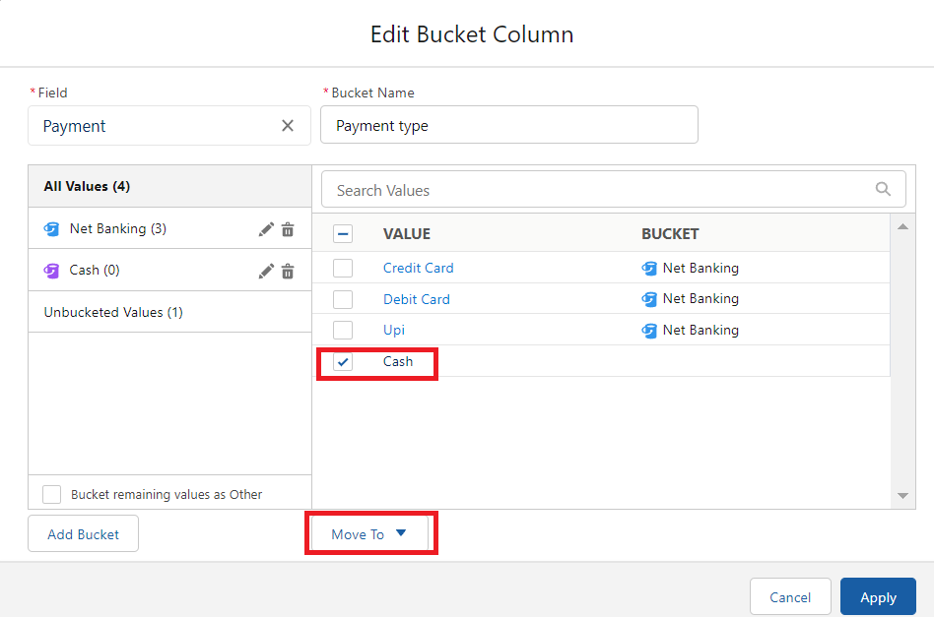

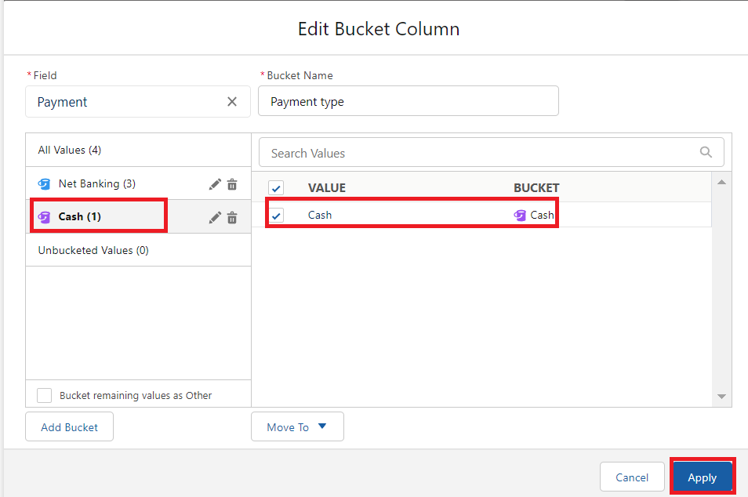

14.In Group Rows Add Payment Type Bucket Field.

15.Click refresh

16.Click Save and Run

17.Give report name – Consultant report

18.Click Save

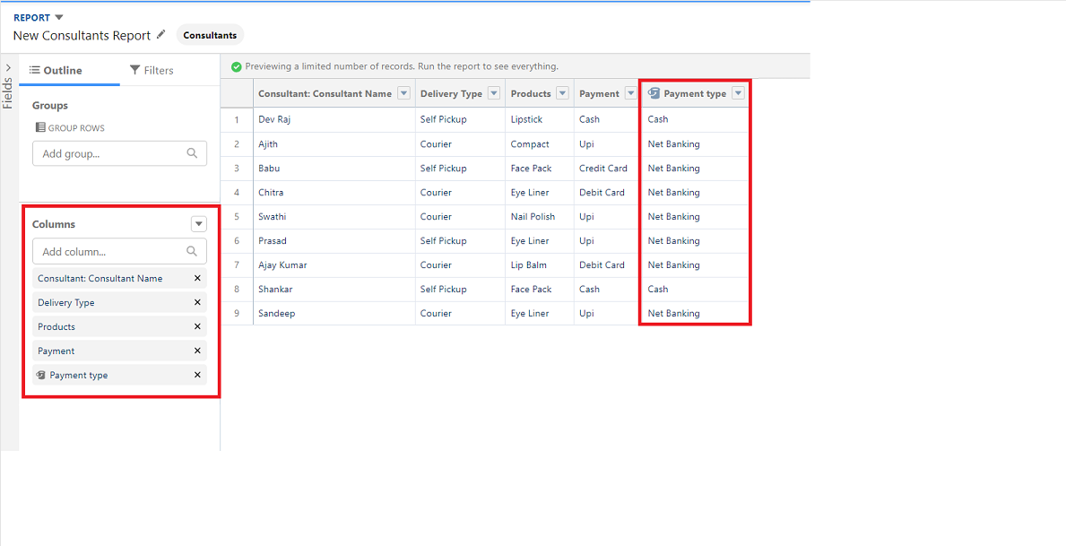

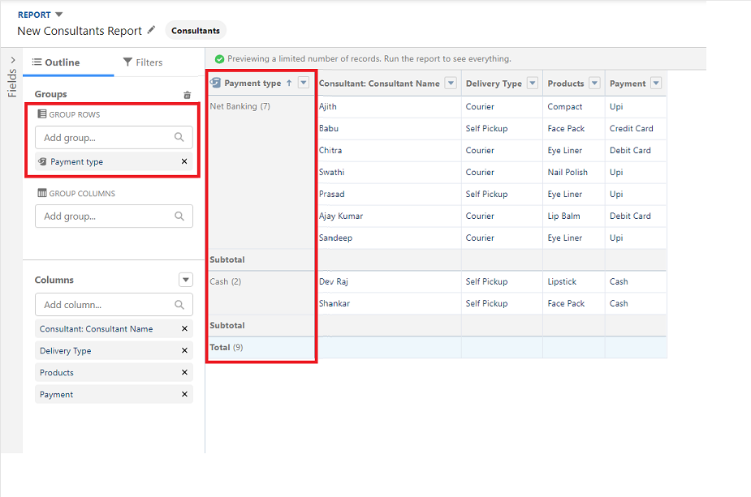

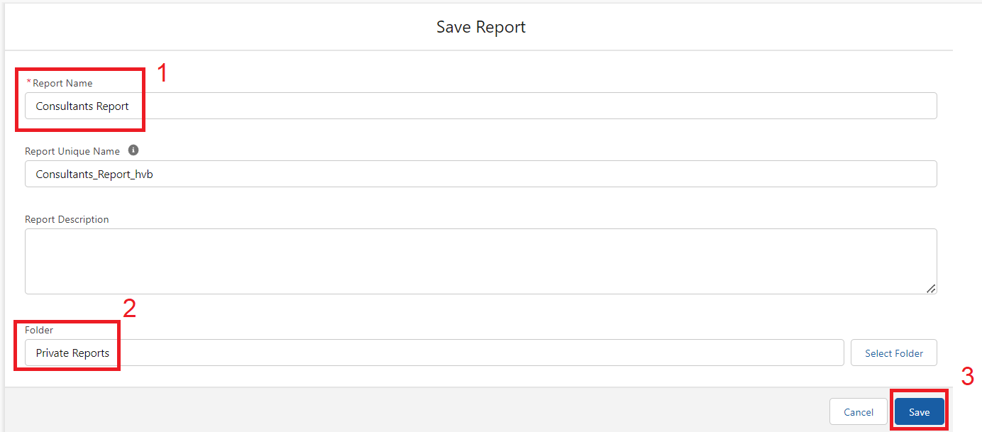

**View Report**

1. Click on App Launcher on the left side of the screen.
2. Search Urban Colour App & click on it.
3. Click on Reports Tab.
4. Click on Urban Colour Report and see records



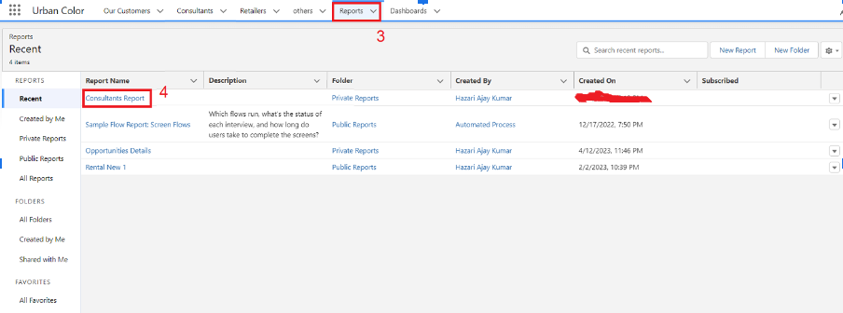

**Dashboards**

Dashboards let you curate data from reports using charts, tables, and metrics. If your colleagues need more information, then they're able to view your dashboard's data supplying reports. Dashboard filters make it easy for users to apply different data perspectives to a single dashboard.

**Create Dashboard**

1. Click on the Dashboards tab from the Urban Color application.
2. Click on the new dashboard.
3. Give name- Consultant Dashboard
4. Click create
5. Give your dashboard a name and click on +component
6. Select the Consultants Report which you created.
7. For the data visualization select any of the chart, table etc. as per your choice/requirement.
8. Click add.
9. Click save.

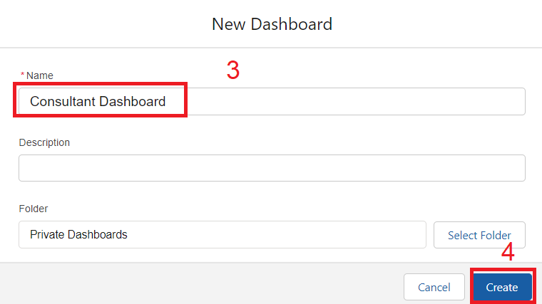

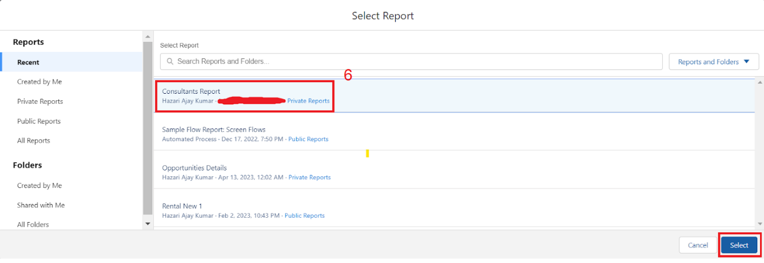

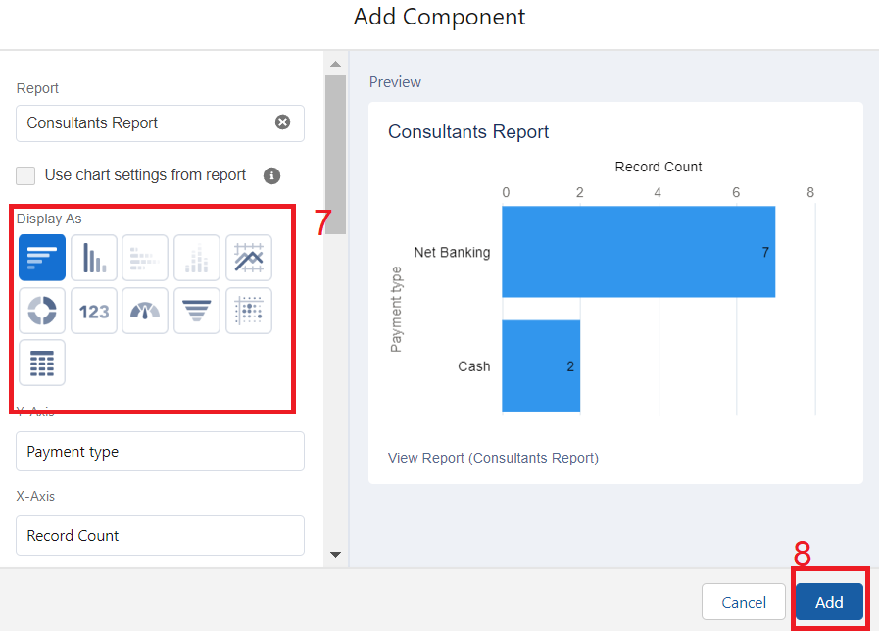

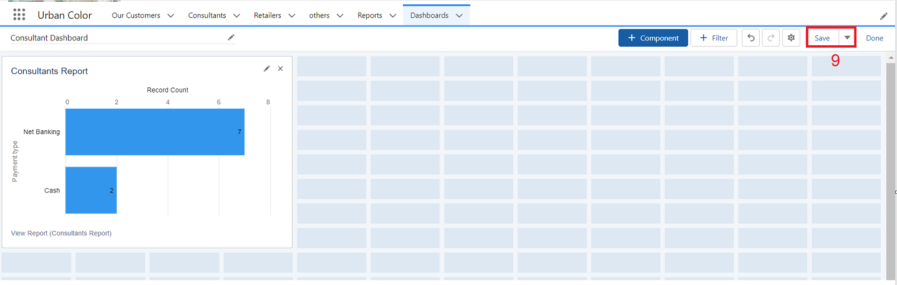

**View Dashboard**

1. Click on App Launcher on the left side of the screen.
2. Search Candidate Internal Result Card & click on it.
3. Click on Dashboard Tab.
4. Click on Candidate Internal Result Card see graph view of records

